

SEMESTER 1, 2019/2020

SSE 4300

SOFTWARE PROJECT MANAGEMENT

GROUP PROJECT

TASK 1: PROJECT PLANNING

|  |  |
| --- | --- |
| GROUP NAME | Black Cockroach VLC |
| LECTURER’S NAME | Dr. Norhayati Binti Mohd Ali |

|  |  |  |
| --- | --- | --- |
| No. | NAME | MATRIC NO. |
| 1 | Muhammad Harith Bin Zainudin (LEADER) | 192171 |
| 2 | Sufi Nukman bin Shakimi | 194092 |
| 3 | Siti Nur Syahirah Bt Mohd Ashri | 193578 |
| 4 | Nur Syafiqah binti Zulkifli | 193575 |
| 5 | Muhamad Amir Hassan Bin Hamzan | 193577 |

TABLE OF CONTENT

**1. Project Overview** **3**

1.1 Background 3

1.2 Scope Description 3

1.3 Objectives 3

1.4 Team Structure 4

1.5 Activities 7

1.7 WBS, Gantt Chart and Network activity diagram 9

1.8 ProWorkflow Overview 13

1.9 References 14

## 1. Project Overview

### 1.1 Background

Automatic student attendance system using a fingerprint recognition approach provides a secure system for taking student’s attendance. Fingerprint features are the best and fastest method for biometric identification. These features are more secure to use and unique for every person that does not change in one's lifetime. For example, every student needs to verify their own thumbprints in order to record their attendance for every class they attend. The development of this system is motivated since the students’ attendance records sometimes have unrecognized signature on the absent student attendance.

### 1.2 Scope Description

This project is to develop the automated student attendance system using a fingerprint. Students only need to use their fingerprint to fill in their attendance to the class. This system uses the automated way so that, the system will recognize the student who attend or not attend the class. This will make the lecturer life easier to know the attendance.

### 1.3 Objectives

o This system takes daily accurate attendance of the student.

o to carry out the analysis of manual processes involved in class attendance.

o This system effectively manages attendance of the student

### 1.4 Team Structure

|  |  |
| --- | --- |
| Position | Role & Responsibilities |
| Project Manager | Responsible for developing a project plan, recruit right resources, lead, monitor and manage teams, determine the methods and technologies to be utilized, and assign tasks to project team members.   * Develop a project plan * Manage deliverables according to the plan * Recruit project staff * Lead and manage the project team * Determine the methodology used on the project * Establish a project schedule and determine each phase * Assign tasks to project team members * Provide regular updates to upper management |
| Programmer | Every sub-team can have its own developer or programmer who is responsible for completing the development tasks of the team.   * Code and test programming for software. * Develop and deploy computer applications. * Execute code builds to test and production environments. * Fix bugs in existing code. * Collaborate with product, design, and marketing teams. * Maintain documentation per company standards. * Provide testing, documentation, training, and support * Resolve user-submitted problems and questions. |
| Analyst | They are responsible for assisting the team members in gathering the requirements for the project and verify project deliverables to ensure that they meet the client requirements.   * Identify all development teams impacted by a requirement or feature request * Communicate clearly to impacted development teams the functionality they need to develop * Conduct cross functional development and requirements meetings * Define clearly the interfaces through which data and messages flow from one subsystem to another * Ensure that the test teams understand the implications for both unit testing and feature testing |
| Designer | A software designer is responsible for problem-solving and planning for a software solution. After the purpose and specifications of software are determined, software developers will design or employ designers to develop a plan for a solution.   * Prepare software design documentation * Drafting design blueprints and documents for programmers * Debugging and maintaining existing software * Building security into design plans to safeguard information * Creating prototypes or models of the software |
| Tester | Software Testers are involved in performing automated and manual tests to ensure the software created by developers is fit for purpose. Some of the duties include analysis of software, and systems, mitigate risk and prevent software issues.   * Analyzing users’ stories and/use cases/requirements for validity and feasibility * Collaborate closely with other team members and departments * Execute all levels of testing - System, Integration, and Regression * Design and develop automation scripts when needed * Detect and track software defects and inconsistencies * Provide timely solutions * Provide support and documentation |
| Team Leader | * Leadership * Decision Making/Judgement * Knowledge * Planning * Influencing * Negotiation * Meeting Management * Communication * Alliance Management |

### 

### 1.5 Activities

For this project with followed the Software Development Life Cycle phase for our project activities. SDLC is the foundation for all software development methodologies, with various activities associated with each level. Activities such as budgets, requirements gathering, and documentation writing, are included in the cycle, as well as the more technical elements. SDLC usually begins with determining customer business needs, which is followed by implementation and testing. The cycle ends when all requirements have been fulfilled. The software development life cycle comprises of five distinct phases.

**Phase 1: Requirement & Analysis**

In this phase, all information and requirement to develop the Automated Student Attendance System Using A Fingerprint Recognition Approach is collected from the stakeholder. So that the product as their expected. Once the requirement gathering is done, an analysis is done to check the feasibility of the development of a product. In case of any ambiguity, a call is set up for further discussion. Once the requirement is clearly understood, the SRS (Software Requirement Specification) document is created. This document should be thoroughly understood by the developers and should be reviewed by the customer for future reference.

**Phase 2: Design**

Once the requirements have been gathered and analyzed this phase the system and software design is prepared from the requirement specifications which were studied in the first phase. System Design helps in specifying hardware and system requirements and helps in defining overall system architecture. System Design also includes the design of databases, user interfaces, and system interfaces. The system design specifications serve as input for the next phase of the model.

**Phase 3: Development:**

After the designing process, developer will start constructing the system using chosen tools and language from the start. The work is divided in modules and actual coding is started. Since, in this phase the code is produced so it is the focus for the developer. This is the longest phase of the software development life cycle.

**Phase 4: Testing**

After the code is developed it is tested against the requirements to make sure that the product is solving the needs addressed and gathered during the requirements phase. During this phase all types of functional testing like unit testing, integration testing, system testing, acceptance testing is done as well as non-functional testing are also done. Any issues that has been found during the testing will be documented and will be fix during this phase

**Phase 5: Implementation**

Once the software testing phase is over and no bugs or errors left in the system then the final deployment process starts. Based on the feedback given by the project manager, the final software is released and checked for deployment issues if any.

### 1.7 WBS, Gantt Chart and Network activity diagram

WORK BREAKDOWN STRUCTURE

|  |  |  |
| --- | --- | --- |
| LEVEL 1 | LEVEL 2 | LEVEL 3 |
| 1. Automated Student Attendance System Using A Fingerprint Recognition | 1.1 Analysis | 1.1.1 Requirement Meetings  1.1.2 Communication with Stakeholder  1.1.3 Document Current System |
| 1.2 Design | 1.2.1 Design Database  1.2.2 Software Design  1.2.3 Interface Design  1.2.4 Specification Design |
| 1.3 Development | 1.3.1 Develop System Module  1.3.2 Integrate System Module  1.3.3 Perform Initial Testing |
| 1.4 Testing | 1.4.1 Perform System Testing  1.4.2 Document Issues Found  1.4.3 Correct Issues Found |
| 1.5 Implementation | 1.5.1 On-Site Installation  1.5.2 Support Plan for the System |
| 1.6 Completion | 1.6.1 System Maintenance  1.6.2 Evaluation |

Table1: Tabular View Work Breakdown Structure

Gantt Chart

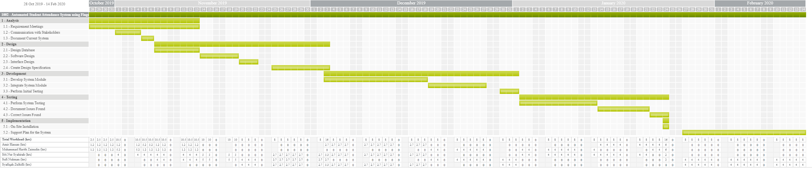

Table 2 (1): Gantt Chart

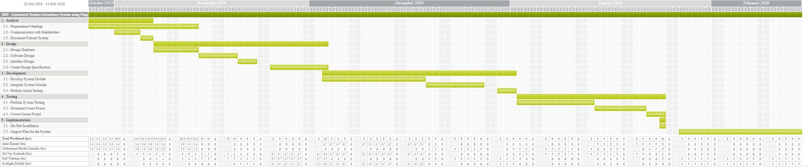

Table 2 (2): Gantt Chart



Table 2 (3): Gantt Chart

Activity Network Diagram

|  |  |  |  |
| --- | --- | --- | --- |
| TASK ID | TASK NAME | DEPENDENCY | DURATION(Days) |
| T1 | Analysis | - | 10 |
| T2 | Design | T1 | 25 |
| T3 | Development | T2 | 30 |
| T4 | Testing | T3 | 23 |
| T5 | Implementation | T4 | 22 |

Table 3: Task Duration and Dependency Table

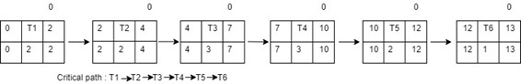

Figure 1: Activity Network Diagram

### 

### 1.8 ProWorkflow Overview

The tool that we have chosen to undertake out project with is called ProWorkflow. ProWorkflow is web-based project management application designed for managers and staff to plan, track and collaborate to improve project delivery. ProWorkflow is now on its 8th iteration.

ProWorkflow includes all the features of a traditional project management solution. In addition, the solution also offers task management, timesheets, templates, notifications and alerts, file sharing, workflow management, contact management, reporting and resource management. ProWorkflow also provides a timeline and availability Tool to help with task scheduling.

ProWorkflow Project Management dashboard displays the graphical summary of ongoing projects. The collaborative feature allows multiple members to work simultaneously. The built-in messaging app allows teams to chat, send notifications, share documents and more.

For our project we use Gantt chart provided by the tool to schedule our project activity for each phase easily with clear and visual representation of time frames. We also able to set which member for each activity in our project and allocation hour for each task.

### 

### 1.9 References

1. <https://www.proworkflow.com/>

### 2.0 Appendix and Meeting

*Picture 1 : Picture 2 : Picture 3: Picture 4:*

*Deciding task leader Reminding about the meeting Memo about meeting Deciding meeting place*

*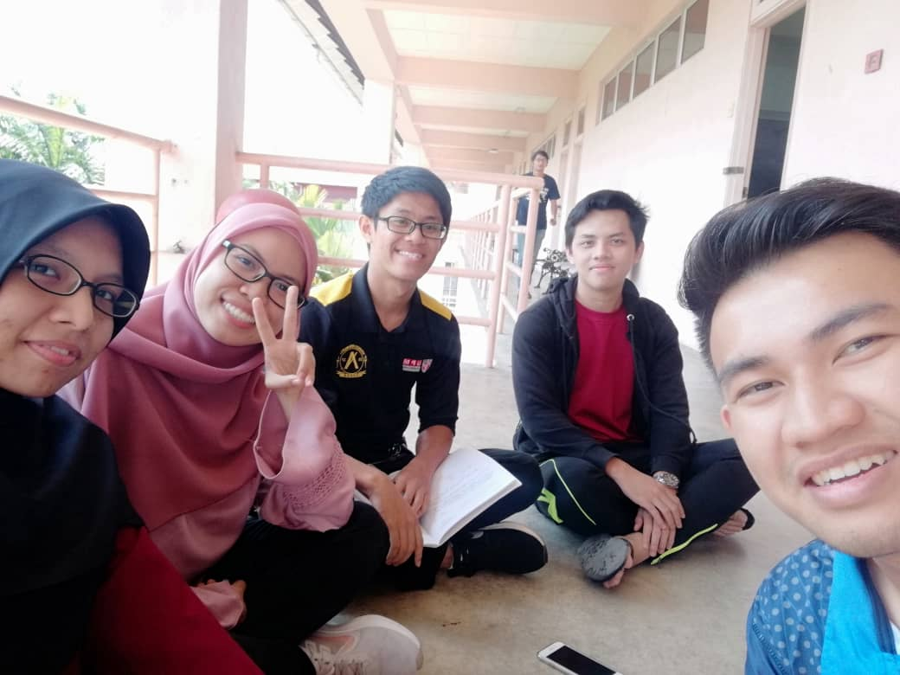1st Meeting*

*Date: 7 October 2019*

*Time: 1.00pm – 2.00pm*

*Duration: 1hr*

*Attendance: All attend*

*Agenda:*

1. *Deciding tool for TASK 1*
2. *Discuss the feature of the tool that have been decide*
3. *Dividing the work to all the team member for task 1*
4. *Decide next meeting*

*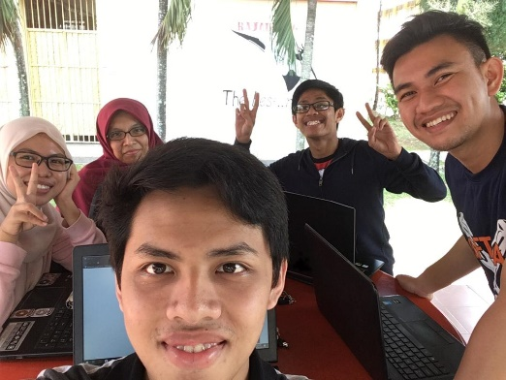2nd meeting*

*Date: 20 October 2019*

*Time: 4.30pm – 6.30pm*

*Duration: 2hrs*

*Attendance: All attend*

*Agenda:*

1. *Proceed with task 1*
2. *Finishing task 1*